 | 
COUNCIL OF  THE EUROPEAN UNION |  |  | Brussels, 16 October 2007
 |  |  | 13887/07
 |  |  | EUROPOL 102

COVER NOTE
from : | Mr. Tung-Laï MARGUE, Director in Directorate-General for Justice, Freedom and Security of the European Commission and Mr. Max-Peter RATZEL, Director of EUROPOL
to: | Mr. Rafael FERNANDEZ-PITA Y GONZALEZ, Deputy Director General of the Council General Secretariat and Mr. António DELICADO, Coordinator EU of the Portuguese Ministry of Justice
Subject : | Transmission of Implementation Plan (Road Map)

Delegations will find in annex the Implementation Plan (Road Map), as transmitted to the General Secretariat on 11 October 2007.

______________________

ANNEX

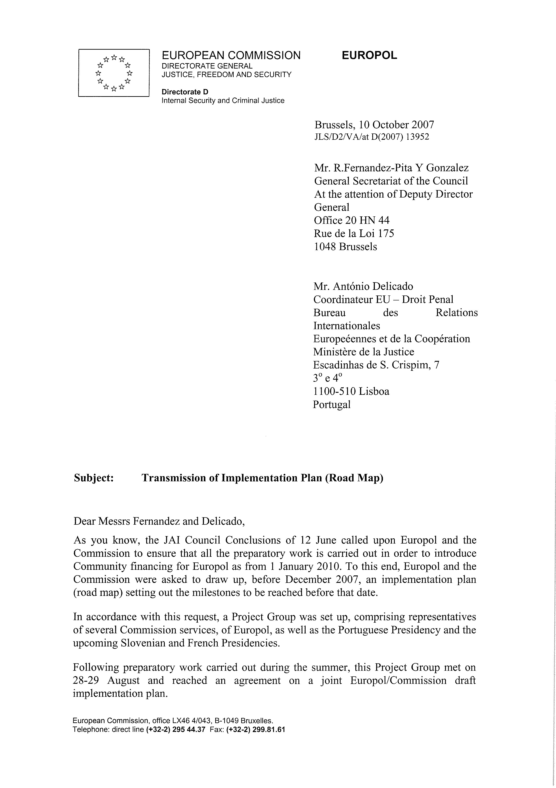


EUROPOL - COMMISSION | 17 September 2007

Cover note

Roadmap for the implementation of the proposal for a Council Decision on Europol

1. Context

1.1. During its meeting on 4 and 5 December 2006, the Council agreed that, as it would constitute a clear improvement of the operational and administrative functioning of Europol, the Europol Convention should be replaced by a Council Decision subject to a full assessment of the following implications:

(a) financing of Europol from the general budget of the European Union

(b) application of the EC Staff Regulations as well as the Protocol on the Privileges and Immunities of the European Communities to Europol Staff guided by the principle of budget neutrality and taking into account the specific requirements resulting from Europol's mandate and tasks.

1.2. Based on the “Impact Assessment” submitted to the Council on 12 June 2007, the Council reached agreement on the following conclusions:

“▪The Europol Convention will be replaced with a Council Decision pursuant to Article 34(2(c) of the TEU and the necessary Council Decision will be finalised by 30 June 2008, at the latest.

▪In accordance with Art. 41(3) TEU and other applicable provisions, Europol will be funded from the Community budget as from 1 January 2010, provided that satisfactory solutions on the following aspects have been found:

- The lifting of immunity for Europol officials when participating in operational activities, especially Joint Investigation Teams

- The principle of staff rotation and the possibility for Europol staff participating in JIT to receive instructions from the team leader

- Clarification of the budgetary consequences, guided by budget neutrality.

▪ Europol and the Commission will ensure that all preparatory work is carried out in order to enable the introduction of Community financing as from 1 January 2010. To this end, Europol and the Commission will draw up an implementation plan (roadmap) which sets out the milestones which have to be reached before that date. The Council will endorse the implementation plan (roadmap) as soon as possible and, at the latest, in December 2007.”

1.3. The tasks stemming from the legal and administrative transformation of Europol into an agency are likely to generate a considerable volume of work for both Europol and the Commission. The exercise will be particularly resource intensive and will require that Europol make the necessary provisions.

2. Outstanding issues to be settled

2.1. Based on the Council conclusions of 12 June 2007, Members States' agreement on the issues below is a pre-condition for the finalisation of the proposal for a Council decision and the Community funding of Europol. The issues are the following:

(a) The lifting of immunities for Europol officials participating in Joint Investigation Teams;

(b) Maintaining bold posts and the principle of rotation in the context of Europol’s new legal framework and the possibility for Europol staff participating in Joint Investigation Teams to receive instructions from the team leader;

(c) The budgetary consequences of Europol’s financing from the Community budget.

2.2. In order to identify solutions to these issues, work will be undertaken by the Presidency and Member States, the Commission and Europol. In particular, a joint Europol and Commission project group is set up to carry out the necessary work.

2.3. Agreement on the above issues should be reached as early as possible in order to enable the finalisation of the proposal for a Council Decision by 30 June 2008 at the latest. The Presidency will submit to the Council, prior to the finalisation of the proposal, a text setting out the possible solutions.

3. Milestones and target dates

3.1. The following key milestones and target dates have been identified:

- Negotiations on the Council Decision on Europol will be finalised by 30 June 2008 at the latest. Consequently, the Council Decision is likely to enter into force during the second half of 2008.

- Prior to its applicability, all essential measures will have to be taken in order to enable Europol to operate on its new legal basis as of 1 January 2010.

3.2. The most important measures are the following:

(a) Preparing for the implementation of the EC Staff Regulations and of the EU Financial Regulation: Europol will be financed from the Community budget as of 1 January 2010 and consequently be subject to the EU Staff and Financial Regulations. As the present legal framework of Europol is distinctively different from the EU framework, not only will the legal basis for Europol’s administration have to be re-created, but also quite substantial administrative changes (e.g. implementation of a new accounting system, adaptation of staff administration systems to EC conditions) will have to be implemented internally prior to applying the new legal framework as of January 2010. Target date: mid 2009.
(b) Adaptation of the Europol acquis: All legal acts implementing the Council Decision which have to be in force before the date of applicability (1 January 2010) will have to be created, revised, discussed and adopted. As the entire existing Europol acquis will be repealed once the Council Decision is applied, the majority of acts constituting this acquis will have to be readopted in order for Europol to have a legal basis for its ongoing activities (approximately 85 legal acts, i.e. Council Acts, Acts of the Europol Management Board and Acts of the Europol Director). Target date: mid 2009.

(c) Transfer of staff under the EU Staff Regulations: Europol, an existing organisation with currently about 500 staff members, will have to prepare for the transfer to the new personnel regime. Europol has to individually inform all staff members thoroughly about the forthcoming changes. The Commission will assist Europol in this process. Target date: end 2009, ongoing from 2010 to 2012 and possibly beyond.

3.3. The milestones and target dates are set out in greater detail in the attached Implementation Plan (see Annex).

4. Monitoring of progress
The Presidency will regularly invite Europol and the Commission to report to the Council on the state-of-play.

5. Annex:
Implementation Plan

Implementation plan (roadmap)

The following milestones must be reached in order to allow for the applicability of the future Council Decision on Europol as from 1.1.2010

 | Milestone | Description/Remarks | Responsibility | Target date
1 | Transfer of staff towards the new contractual regime | Basis: article 56 of the proposal for a Council Decision on Europol.  Agreement between Commission and Europol on the exact nature of the transfer with a view to facilitating the changeover.  The outcome should inform the discussion in Europol Working Party on article 56. | Commission and Europol | By 4th quarter 2007 – 1st quarter 2008
2 | Establishment of the budget for 2010 | Agreement between Commission and Europol on the content of the 2010 budget which form the basis for Europol's expenditure in 2010. | Commission and Europol | By 1st quarter 2009

3 | Replacement of the Europol acquis | The acquis includes acts necessary for the implementation of the Council decision and for the continuation of Europol's operational work as from 1.1.2010.  The acts are estimated to be: 7 Council Acts, 33 Management Board Acts and those requiring the Management Board's authorization, 45 Acts of the Director.  In certain cases the adaptation involves complete redrafting, in others, the revision is simpler. | Europol, Commission and Council | By end of 2nd quarter 2009
4 | Other measures to be elaborated before applicability | Basis: Article 58 of the proposal for a Council Decision on Europol. | Europol (Management Board and Director) + Joint Supervisory Body  with the assistance of Commission; Council. | By end of 2nd quarter 2009
 | (a) the rules and obligations of liaison officers; | Basis: Article 9, paragraph 4, of the proposal for a Council Decision on Europol.  These rules define the status, rights and obligations of Member States liaison officers at Europol.
 | (b) the rules applicable to Analysis Work Files; | Basis: Article 14, paragraph 1, subparagraph 3 of the  proposal for a Council Decision on Europol.  These rules govern the conditions under which the  Analysis Work Files can be used.
 | (c) the rules regarding the international relations of Europol; | Basis: Article 25, paragraph 1 of the proposal for a  Council Decision proposal on Europol.  These rules define the conditions and procedures  necessary for the establishment of relations between  Europol and Third Parties.
 | (d) the rules regarding the relations of Europol with Community or Union related bodies and agencies; | Basis: Article 25, paragraph 2 of the proposal for a  Council Decision on Europol.  These rules define the conditions and procedures  necessary for the establishment of relations between  Europol and Community or Union related bodies.
 | (e) the rules implementing the Staff Regulations; | Basis: Article 36, paragraph 8, d) of the proposal for a  Council Decision on Europol.  These rules are necessary for the application of the Staff Regulations.
 | (f) the rules on the selection and dismissal of the Director and Deputy Directors; | Basis: Article 37, paragraph 3 and 7 of the proposal for a  Council Decision on Europol.
 | (g) the rules on confidentiality; | Basis: Article 39, paragraph 1 of the proposal for a Council  Decision on Europol.  These rules govern the access, handling and transmission of classified information.
 | (h) the financial rules. | Basis: Article 36, paragraph 8, e) and 43 of the proposal for a Council Decision on Europol.  All agencies have to adopt a Financial Regulation based on the model framework Financial Regulation for Agencies. The internal audit function can be clarified in this context if it is not dealt with in the Council Decision itself.
5 | Organizational preparations and change management | Preparation, training and implementation of administrative measures necessary to apply the new staff regime and financial framework. | Europol and the Commission | 3rd quarter 2009
6 | Pension Fund and Social Security | Arrangements relating to the Pension Fund established for staff under Europol contracts and to their Social Security system. | Europol and the Commission | 3rd quarter 2009

______________________________

Which do not fall under the measures dealt with under item 3

